### Mobile Money Ecosystem

Poverty is more than just a lack of money. It involves a lack of access to the instruments and means through which the poor could improve their lives. Exclusion from the formal financial system has increasingly been identified as one of the barriers to a world without poverty. In many developing countries, more than half of households lack an account with a financial institution, while small firms frequently cite difficulty in accessing and affording financing as a key constraint on their growth. In a report jointly released by the Microfinance Information Exchange (MIX) and MasterCard Foundation, it was revealed that over 80 million Nigerians do not have access to financial services. This exclusion does not necessarily mean that the poor lack active financial lives: in fact, the fragility of their situation has led to the development of sophisticated informal financial instruments. However, the use of only informal instruments means that the poor are limited in their ability to save, repay debts, and manage risk responsibly. On a macroeconomic level, these financial constraints on the poor can exacerbate inequality (Demirgüç-Kunt, Beck, and Honahan 2008).

In another similar study by the Enhancing Financial Innovation & Access (EFInA) in 2012(Access to Financial Services in Nigeria 2010) ,it was revealed that there was only a marginal increase in the number of those served by formal financial market from 35 percent in 2005 to 36.3 percent in 2010, five years after the launching of the microfinance policy. The survey showed that the main barriers why people do not have bank accounts include unsteady income distance to bank branches, etc. The central Bank of Nigeria (CBN) in 2012, also puts the ratio of bank branch to the total population at 24, 224 persons. Unfortunately, robust economic growth cannot be achieved without putting in place well-focused services that increase access of poor and low income earners to factors of production, especially credit. Financial inclusion is now a common objective for many central banks among the developing nations, particularly as it remains a major factor in driving economic growth they are committed to. In its desire to extending financial services to a wider segment of Nigerians, the CBN identified mobile telephony as a veritable tool for addressing financial inclusion). Since mobile phones have become widely acceptable and used in the country; The ubiquity of cell phone services offer the possibility of service in remote areas of a country where it would be otherwise economically unsustainable to provide banking services. These services could enhance financial inclusion especially when appropriate model(s) is/are well implemented and adopted. It is in this regard that this study looks into models of mobile money services and provides policy recommendation. The rest of the study proceed as follows; following the introduction above is stylized facts in section two. Theoretical issues and Review of literature is undertaken in section three, Section four discusses expected economic benefits of the services Models of mobile money services are examined in section five. .While section six offers policy recommendation and concludes.

2.0 STYLIZED FACTS

The Mobile Money Transfer program, was jointly launched by the GSM Association (GSMA) and Western Union in October 2007, there are now more than 120 mobile money projects being undertaken in about 70 emerging markets. The rapid rise in the growth of mobile technology throughout the world is a phenomenon that has been particularly remarkable among poor people, largely because of the prepaid model. As a result, all classes of society now have access to financial services as people become increasingly familiar with a mobilemoney system. In fact, mobile technology, viewed as a payment or banking channel, has the potential to allow two important questions to be addressed at the same time: on the demand side, it represents an opportunity for financial inclusion among a population that is underserved by traditional banking services. On the supply side, it opens up possibilities for financial institutions to deliver a great diversity of services at low cost to a large clientele of the poorest sections of society and people living in remote areas. (Beshouri et al, 2010). The lack of access to formal banking in the mass market in Africa has opened the door for mobile operators to build successful mobile payment services. The gap between banking penetration and mobile penetration means that while many people do not have access to financial services, they do have a mobile phone. Capitalizing on the phenomenal growth of mobile telecommunications in Africa, a number of service providers are already active in deploying mobile banking services to tap the demand from the large unbanked population. In November 2012, the United Nations Conference on Trade and Development (UNCTAD) disclosed that 40 million mobile money users currently exist in Africa. This figure will rise to 1.2 billion by 2015. According to the GSMA, as November 2012, the trade association for mobile operators, the number of mobile phone users has exceeded credit card users by 50% while the ratio of mobile phone users to automated teller machines (ATMs) users is 2,000 to 1. In addition, there is a sizeable migrant worker market in developing economies such as Africa, Asia and the Middle East, where low-income groups are seeking better working opportunities in developed nations. This creates a substantial need for systems to enable these workers to send money back home to their families. According to the World Bank, recorded remittances to developing countries were estimated at US$240 billion in 2007 (double the value of 2002). This represented three-quarters of the world’s total remittance inflows. India, China, Mexico and the Philippines were the top four remittance- recipient countries with a combined value of US$95 billion. Mobile money transfer therefore extends remittance services to billions of the under banked population. Kenya is currently the dominant player in Africa’s mobile payment markets with over 20 million subscribers. Uganda’s mobile money market too has also expanded to an estimated 1.5 million users between three providers. Additionally, 37 per cent of South Africa’s cell phone users also use mobile banking services. According to data from the GSM Association, most of the 100-plus deployments of mobile money systems have been in developing countries, with around half in Africa alone ( see **figure 1** below).

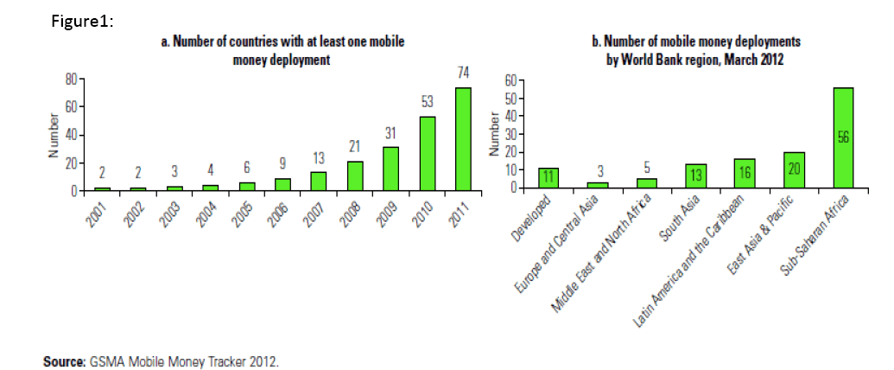

**Figure 1**

In a globalized world, where current migrations occur at a very large scale, remittances and remote payments are an important use of mobile money. Worldwide flows of remittances reached the amount of $318 billion dollars in 2007. Latin America and the Caribbean (LAC) region remains the largest recipient of (recorded) remittances (Rhata, Mohapatra, Vijayalakshmi & Xu, 2007). According to the Inter-American Development Bank (IDB, 2008), LAC received remittances of USD$ 65,000 million. Mexico is the leading receiver (24 million), while for countries like Guatemala, El Salvador, Honduras and Nicaragua, remittances account for more than 10% of its Gross Domestic Product (GDP). However, the majority of the populations in these countries do not have a bank account. For example in México the remittance recipient with bank account is 29%, in Guatemala 40%, in El Salvador 31%, in Colombia 50% and in Peru 37% (IDB, 2008). The lack of access to formal banking in the mass market in Africa has opened the door for mobile operators to build successful mobile payment services. The gap between banking penetration and mobile penetration means that while many people do not have access to financial services, they do have a mobile phone. Capitalizing on the phenomenal growth of mobile telecommunications in Africa, a number of service providers are already active in deploying mobile banking services to tap the demand from the large unbanked population.

Mobile money applications offer a channel to expand traditional services and extend access to multiple segments including underserved or unserved groups. These applications address the very different banking needs for both the banked population in developed markets and the unbanked population in developing economies such as Asia, Africa and Latin America. In developed markets, the service is at the initial stage and is seen as a convenience that does not generate high revenues, but one on which to build value-added applications. In emerging markets, the large rural populations provide a perfect base to tap the unbanked group with no bank account but a mobile phone (GSMA 2012).

**2.1 An Overview of Mobile Money Services in Africa**

The lack of access to formal banking in the mass market in Africa has opened the door for mobile operators to build successful mobile payment services. The gap between banking penetration and mobile penetration means that while many people do not have access to financial services, they do have a mobile phone. Capitalizing on the phenomenal growth of mobile telecommunications in Africa, a number of service providers are already active in deploying mobile banking services to tap the demand from the large unbanked population There is strong evidence that these services can improve access to formal financial services in developing countries most especially in Africa where financial exclusion is rather high (GSMA 2011).

The story of the growth of mobile telephones in Africa is one of a tectonic and unexpected change in communications technology. From virtually unconnected in the 1990's, over 60 percent of Africans now have mobile phone coverage, and there are now over ten times as many mobile phones as landline phones in use (Aker and Mbiti, 2010). Even with the story of mobile phones' growth as a background, the growth of M-Pesa is startling. M-PESA (“M” for mobile, “pesa” is Swahili word for money) is a mobile phone–based money transfer service launched in 2007 in collaboration with Kenya’s dominant mobile network operator, Safaricom. M-PESA was started and is owned by Vodafone, which is the majority shareholder of Safaricom. M-PESA has been highly successful and, along with two m-money companies in the Philippines, is the best example of a typical m-money service for the unbanked and underbanked. Initially launched in 2007 for person-to-person (P2P) transfers, by 2010, M-PESA had more than 9.4 million customers (**figure2**) and more than 18,000 agents, and accounted for US$5.27 billion in P2P transfers. There is scarcely a household in Kenya that is not an M-PESA user. Between 2009 and March 2010, more than 13 percent of the Kenyan gross domestic product (GDP) was transferred through M-PESA. The service allows users to deposit money into an account stored on their cell phones, to send balances using SMS technology to other users (including sellers of goods and services), and to redeem deposits for regular money. Charges, deducted from users’ accounts, are levied when e‐float is sent, and when cash is withdrawn. As a money transfer service, M-PESA started by serving the needs of the many families split between rural and urban areas. It has since grown to provide many other financial services.

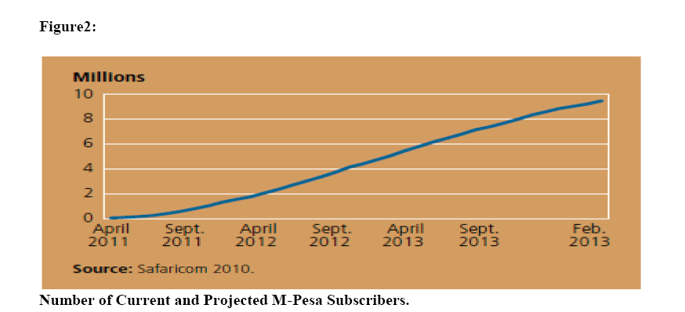

**Figure 2**

Following on from the success in Kenya, Vodafone has replicated the M-PESA solution in Tanzania through its partnership with Vodacom. South Africa In 2005, South African based MTN — the largest mobile operator in Africa — teamed up with Standard Bank – the largest banking group in Africa — to form MTN Banking which at the time was one of the first truly mobile banks globally. The rationale behind this joint venture was to bring a large number of the previously unbanked population into the formal banking sector in a low cost and easily accessible way. Launched in December 2004, Wizzit, a startup mobile banking provider in South Africa, is targeting rural low-income consumers. Wizzit offers a low-cost transactional bank account to unbanked and underbanked people to make person-to-person payments, transfers and prepaid purchases, independent of mobile operators. In November 2007, the International Finance Corporation, a member of the World Bank, acquired 10% of Wizzit as part of its efforts to extend banking services to the poor. African telecom company Zain is also attempting to create a borderless mobile banking network across Africa. It has launched its mobile banking product, Zap in Kenya, Tanzania and Uganda, with plans to roll out services to all of its African operations. Partnering with leading international and regional banks including Citigroup and Standard Chartered, Zap will be included as part of Zain’s cross-border One Network service. Its recent alliance with the money transfer giant Western Union to link its platform to the Western Union’s global agent network has further strengthened the initiative, allowing customers to receive cash in their mobile accounts or at a Western Union agent location.

3.0 THEORETICAL ISSUES AND REVIEW OF LITERATURE

The definition of “mobile money” varies across the industry as it covers a wide scope of overlapping applications. In general, mobile money is a term describing the services that allow electronic money transactions over a mobile phone. It is also referred to as mobile financial services, mobile wallet and mobile payment.(Ernst &young 2009).

A wide range of mobile money applications have developed over time;. Some of which are;

**1. Mobile banking** — use of a mobile phone to remotely access a bank account, primarily for account balance checkup and bill payment services

**2. Mobile money transfer (remittance)** — a peer-to-peer application making use of a mobile phone to send money to family or friends, primarily across international borders

**3. Mobile commerce (payment)**— use of a mobile phone to perform financial transactions for purchases or sales, either remotely or on-site, retrieve promotion information or coupons, and deliver gift items.

Kim et al., 2009; Tiwari and Buse, 2000 Luo, Li, Zhang and Shin 2010, defined mobile banking as an innovative method for accessing banking services via a channel whereby the customer interacts with a bank using a mobile device (e.g. mobile phone or personal digital assistant (PDA)). Mobile Commerce (m-commerce) is defined as a business transaction conducted through mobile communication networks or the Internet (Siau and Shen, 2003). M-commerce can offer value to consumers by providing convenience and flexibility through time and place independence (Kim, Shin and Lee, 2009; Venkatesh, Morris, David and Davis, 2003).

Mobile banking is an application of m-commerce which enables customers to access bank accounts through mobile devices to conduct and complete bank-related transactions such as balancing cheques, checking account status, transferring money and selling stocks

Since Solow’s (1956) seminal contribution to the theory of economic growth, and that of, Romer 1986 and Lucas, 1988, economists have understood that higher rates of adoption of modern technologies may accelerate the development process. There are a significant numbers of studies which have demonstrated the relevance of mobile telephony in economic and social development in developing countries. Among these studies, there are those which seek to identify how mobiles may contribute to economic growth as well as to poverty reduction. At the macroeconomic level, Thompson & Garbez (2007) identify a positive impact of mobiles on productive efficiency in developing countries while Waverman, Meschi, & Fuss (2005) find that the mobile dividend in developing countries is higher than in developed countries given that it is largely the only source of communication.

Robert Jensen’s study on the fisheries market is perhaps one of the most influential papers that, from a microeconomic perspective, analyses the impact of ICT on welfare. Through a weekly survey applied in three districts in Kerala during six years, Jensen finds a significant positive impact of information in these poorly developed markets. He finds that the addition of mobile phones reduced price dispersion, waste and increased fishermen’s profits and consumer welfare. These findings offer evidence that counters the criticism ICT should not be a priority for poor countries that lack access to health and education. (Jensen, 2007 p. 919). Recently, there has been a number of surveys that explore if and how mobile phones are helpful to diminish poverty by identifying the patterns of use by poor income groups in developing countries. (Donner, 2007; Horst & Miller, 2006; Vodafone, 2005; Ovum, 2006; Bhatia, Bhavani, Chiu, Jnakiram, Silarsky, 2008). The application of surveys by Horst & Miller (2004) in Jamaica and Paragas, (2005) in the Philippines show that Diasporas use mobile phones to communicate with family for both economic and social reasons. Donner finds that mobile ownership increases the income of micro entrepreneurs in Rwanda by increasing communication and enriching social networks. In this same area, Molony (2006) finds that mobile phones are used by micro entrepreneurs in Tanzania to manage reputation while creating virtual offices.

Aker and Mbiti (2010) research first examines the evolution of mobile phone coverage and adoption in SSA over the past decade. Theyidentify the main channels through which mobile phones affect economic outcomes and appraise current evidence of its potential to improve economic development; According to the authors, Mobile telephony has brought new possibilities to the continent. Across urban-rural and rich-poor divides, mobile phones connect individuals to individuals, information, markets, and services. These effects can be particularly dramatic in rural SSA, where in many places mobile phones have represented the first modern telecommunications infrastructure of any kind. Mobile phones have greatly reduced communication costs, thereby allowing individuals and firms to send and to obtain information quickly and cheaply on a variety of economic, social, and political topics. An emerging body of research demonstrates that the reduction in communication costs associated with mobile phones has tangible economic benefits, improving agricultural and labor market efficiency and producer and consumer welfare in specific circumstances and countries. Hartsenko (2004) makes a cross-country comparison of the use of the different payment instruments (such as Mobile phone, Phone bank, Internet bank, Bank card, among others) in the Baltic countries. The author applied regression analysis to identify the effects of individual characteristics on people’s using specific electronic payment instruments and analyzed the impact of consumer characteristics on the use of payment instruments in Estonia. The results show a strong effect of demographics characteristics (age, sex, education, occupation living place, and personal income) on consumers’ use of payment instruments.

Ivatury and Mas (2008) provide additional evidence about the early uses of mobile phones as financial service platforms. Cost reduction, which can be passed on to the user, is a major benefit. In the Philippines, “a typical transaction through a bank branch costs the bank US$2.50; this would cost only US$0.50 if it were automated by using a mobile phone.”

In Pakistan, Tameer Bank estimated that opening a bank Branch in a Karachi slum would cost thirty times what a retail agent would cost, and monthly operating costs would be US$28,000, compared with US$300 for an agent. Despite the lower costs and higher availability, the authors estimate that“ less than 10 percent of all branchless Banking customers are poor ,and new to banking, and are using channels *For financial services” other than paying bills, purchasing airtime, or receiving*government payouts. Most usage is for payments, as opposed to savings or credit, and the authors argue this is due to a combination of advertisements and perceptions that are both biased towards payments.

4.0 EXPECTED BENEFITS OF MOBILE MONEY SERVICES

Nigeria’s financial system may be up for greater contribution to the nation’s overall development as the mobile money platform shows brighter prospects. Nigeria may indeed be positioning herself to become the largest mobile payment market in sub-Saharan Africa (EFInA 2012). FINANCIAL transactions by Nigerians through the mobile money platform as at December 2012 in the country currently stand at N228 million .Besides, verified mobile money agents currently stand at 3000 and are expected to increase to 50,000 by 2015 (Ministry of Communications Technology, Nigeria) total value of mobile money transactions have hit N228 million and is expected to increase to N151 billion by 2015.M-payment through mobile phones, has been identified as a viable tool to provide basic financial services to millions of unbanked populations in urban and rural communities in Nigeria, and will become a booming industry. Indeed, financial inclusion has been identified as a plank to lift a large fraction of the unbanked population globally out of poverty and hunger and bring them into the financial system.

*Mobile Money will create a cheaper and more accessible electronic payment ecosystem that will broaden and deepen the financial sector. More importantly, an effective agent network will ensure that more people are financially included by increasing the number of access points for transactions, and reducing the cost of transacting, especially in the rural areas. A critical success factor for the uptake of Mobile Money is the proliferation of ubiquitous agents in as many communities as possible, so that consumers can transact safely and easily, close by to their home or place of work.* More so, several benefits accrue with the combination of mobile phones and financial services: it enhances commerce; it allows for microfinance, it allows ease of remittances, it offers security that cash does not and, possibly, it could serve as a replacement for debit and credit cards. It will provide banking services for the unbanked. Commerce is enhanced because it becomes much easier to pay for goods and services by the use of the mobile phone. There is no need to go to a bank to withdraw money, it is in the phone.

The benefits of Mobile Money Services are legion; Apart from financial inclusion and enhancing of ecommerce other expected benefits include jobs creation, financial empowerment; increase in the income of rural dwellers, absence of CoT(Cost of Transaction).In fact, by bypassing banks and other financial institutions that charge fees on money transfers and the truncation or voiding of the long distances usually traveled to deliver money, the system could save money that could be channeled to other ventures. Mobile money services are also able to raise the tempo of business activities and move cash on to the hands of people who can use it quickly, cheaply and efficiently.

*Mobile Money Operators (MNOS) therefore, have a huge responsibility for expanding financial services in Nigeria. There is the need to make use of technology which will enable us leapfrog development; taking banking services to communities where it would not have been economically feasible in the past using traditional bricks and mortar. The Central Bank of Nigeria (CBN) is extremely proactive and has put in place the levers of success required for the MMOs to succeed in their endeavors.*

5.0 MODELS OF MOBILE MONEY SERVICES

Many potential models have been described for mobile money applications. Among the most common ones are operator-centric and bank-driven models, given the fact that these industries have control over a mass customer base (Ernst and Young 2009). The mobile money ecosystem develops in different ways in each country, and between different service providers and mobile network operators, as technology advances.

**Operator-Centric Model**

In this model, the mobile network operator (MNO) offers the technology, operates the transactions and compensates the system. The MNO will reap the benefits of its Customer base and already established billing relationships. Mobile network operators will also benefit from additional service fees as well as increased valueadded services to the consumer who would be able to conduct quick, convenient payment transactions.

This benefit may lead to improved customer loyalty, increased revenues and a potential reduction in customer turnover. However, strong partnerships with merchants are essential for this mode to operate successfullyl. The operator-centric model has played an important role in bringing M-payments to its current stage. NTT DoCoMo (Japan), Mobipay (Spain) and Mobikom (Austria) are some of the international examples of operator-centric models. **Figure 3**below illustrates how operator-centric model works.

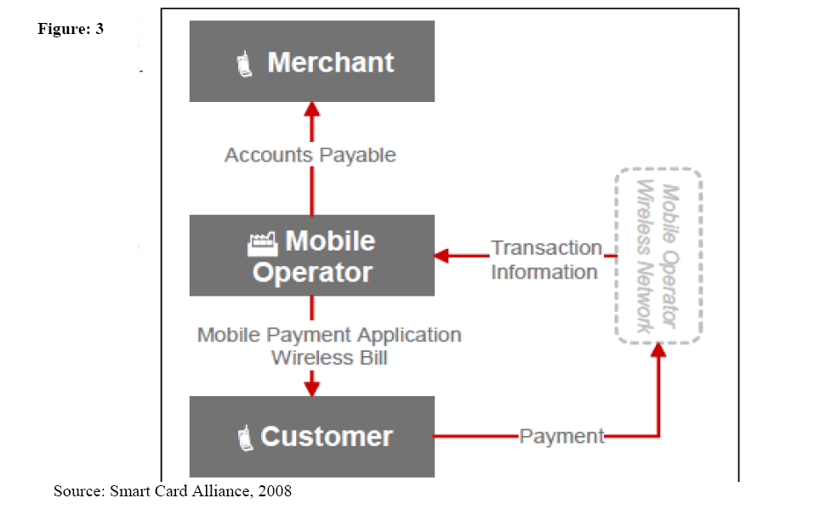

**Figure 3**

**Bank-Centric Model**

The bank-centric model can be considered an evolution of the credit-card model. Customers continue the same relationship with their bank, which provide them with the same services in a more convenient way, i.e. by using their mobile phone. A bank-driven model implies that one or more banks establish a mobile payments service based on already existing payment processes. Payments will be processed over mobile networks (remote payments for example via SMS for electronic goods or directly at the PoS (e.g. via Near Field Communication). Besides the need to encourage their customers – mainly consumers and merchants – to utilise the service, banks will further have to partner with mobile operators and agree on an attractive revenue-sharing system. **Figure 4**below illustrates bank-centric model;

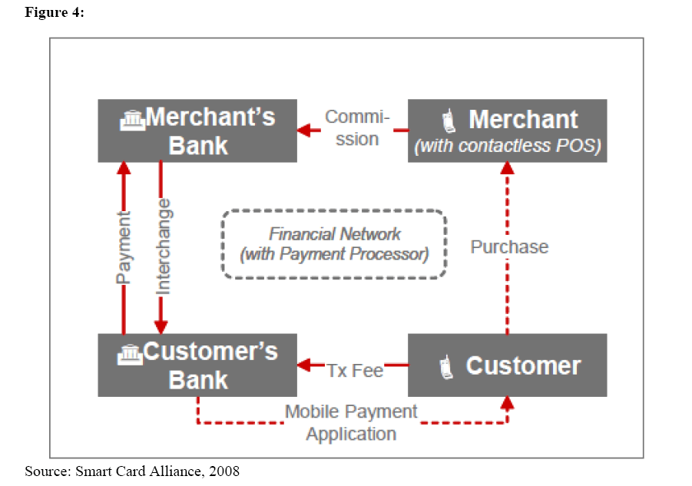

**Figure 4**

There are some bank-centric models evolving on a global level as well, like ClearXChange and Cash Edge. ClearXChange, a joint venture of Wells Fargo, Bank of America and JPMorgan Chase, is a stepping stone to achieve bank dominance in the M-payments value chain.

**Collaboration Model**

The Collaboration Model involves collaboration among banks, mobile operators and other stake-holders in the mobile payments value chain, including a potential new stakeholder -- a trusted third party to manage the deployment of mobile applications. This model includes two possible scenarios:

**Scenario 1:** A mobile operator partners with one bank to offer a bank-specific mobile payments service.

**Scenario 2:** Industry associations representing mobile operators and financial institutions negotiate and set standards for applications that reside on secure elements in mobile de-vices, allowing multiple card types from different banks to be used.

In both cases; Near Field Communication-enabled mobile devices and compatible POS devices are deployed that meet the standards set by the partner bank or industry associations. Potential sources of revenue include merchant commissions, merchant and consumer trans-action fees, new customer acquisition fees, and marketing fees. The amount paid and collected by each stakeholder is the source of considerable contention. Generally it is expected that merchant fees are split between banks, mobile operators, and perhaps third-party trusted service managers (TSMs). Comparable models exist in the credit card industry for customer acquisition and marketing fees between partners. **Figure 5** below is an illustration of collaboration model;

There are no concrete examples of real-world commercial rollouts of the Collaboration Model, and the technology is still in the trial phase in most parts of the world. Although the Collaboration Model is ideal because it allows each stakeholder to focus on their core competencies, the model has the most complex implementation as it requires agreement on revenue-sharing models.

**Peer-to-Peer Model**

The Peer-to-Peer Model is an innovation created by payments industry newcomers who are trying to find ways to process payments without using existing wire transfer and bank card processing networks. The ability to send money from one person to another, even across great distances, has existed for many years through providers such as Western Union. While the Internet has made this service even more convenient, the high fees associated with the transfers can make them cost prohibitive and not for every-day use. Internet bill payment services provided by most banks have made remote payments to merchants convenient, but cannot be used for real-time purchases. Mobile phones with peer-to-peer capabilities overcome these obstacles. This model is significantly different from the other models discussed in this study. Bank-Centric, Operator-Centric, and Collaboration Models are methods for bringing contactless payments and mobile loyalty to the marketplace. The Peer-to-Peer Model is a way to use the mobile phone to eliminate the existing payments ecosystem that consists of POS terminals, the ISOs and acquirers that deploy them, and the processors and payment networks that route and settle the transactions. While numerous peer-to-peer mobile payments implementations have been announced in India and Asia/Pacific, the two main deployments in the U.S. are PayPal Mobile and Obopay. **Figure 7** below illustrates peer-to-peer model;

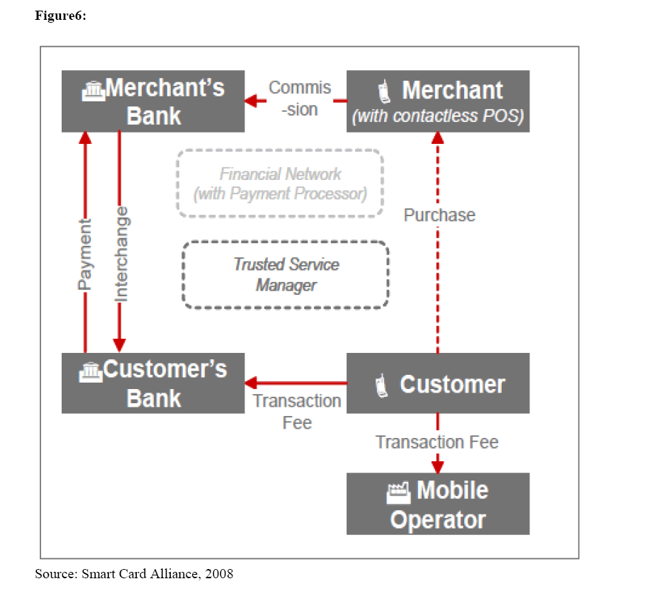

**Figure 6**

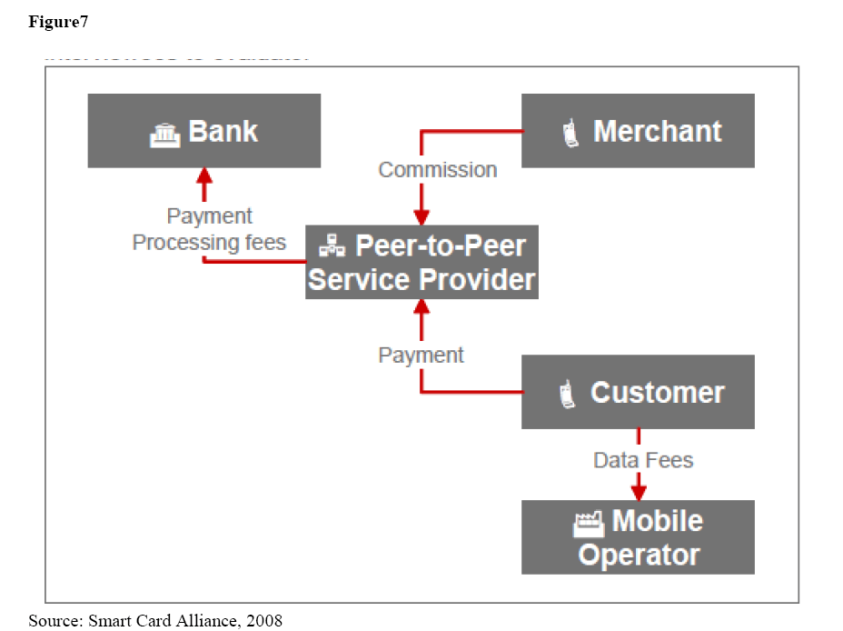

**Figure 7**

**Models of Mobile Money Services in Nigeria**

The Nigerian mobile payments market is still in its infancy and the facts, statistics and predictions are still attempting to pinpoint when mobile payments will be the subject of mass adoption .For instance, few out of licensed mobile money operators as at November 2012, had commenced operations among them are; GTBank (in strategic partnership with MTN NIGERIA and FORTIS),United Bank of Africa(UBA), FirstBank PLC, Pagatech etc.(CBN 2012). As a result, the mobile payments landscape is continuing to evolve with various business models. This section highlights models that major stakeholders have provided. The business models have been categorised according to the critical roles played by the participants under different scenarios. These include; who is legally responsible for the deposits, who bears the reputational risk (i.e. whose brand is more exposed to the public), whether deposits can be accessed through agents or only through bank branches, and who carries out the payment instruction. The Nigerian models are discussed below;

**Bank-Focused Model**

In this model, a bank delivers banking services to customers using the mobile phone as a delivery channel. This model can only be deployed by a licensed deposit-taking financial institution. The Lead initiators are licensed deposit taking financial institutions such as DMBs, microfinance banks and discount houses. Participants include Initiating banks, its ICT partners and customers. Based on this model, the Lead Initiator shall adhere to put in place adequate measures to mitigate all risks that could arise from the deployment and use its mobile payment solution.

**Bank-Led Model**

This model allows a bank, or a consortium of banks, partnering with others organizations, jointly seeking to deliver banking services by leveraging on the mobile banking system. The model is only applicable to a scenario where there exists collaboration between a licensed deposit-money bank(s) and an organization duly verified by the partner bank(s).

The Lead Initiator in this model is a bank or consortium of banks and its partners with other organizations. The roles and responsibilities of the participating organizations are restricted to their area of core competence e.g provision and management of the necessary technology requirement as well as agent network management and provision.

**Non-Bank -Led Model**

This model allows a corporate organization that has been duly approved by CBN to deliver mobile payment services to consumers. This model is only applicable to any organization other than a licensed deposit money bank and telecommunication companies. The Lead initiator in this model shall be organization other than a DMB or Telco e.g Switches and payment service providers. The roles and responsibilities are; they shall register with CBN as a payment service provider, ensure its network is in full compliance with the regulatory Framework, provides the CBN with open access for on the spot monitoring, provides a quarterly assessment report on the performance of the organization. **Table 1** below summarizes the Nigerian model of mobile services;

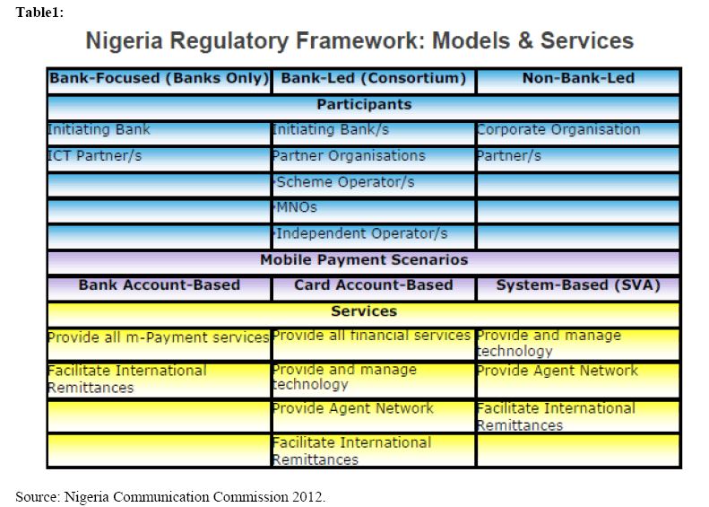

**Models Assessment**

There is no single model that fits all markets. The types of model adopted depends on a wide range of external factors, including the market composition, openness of regulatory regimes, maturity of related industry sectors, market dominance of the participants and potential cooperation within the value chain. Given the specific environment of each models discussed above, it becomes rather impossible to use a single scale to rank efficiency of these models. However there seem some semblances between models of mobile money services in developed economies and that of Nigeria. For instance, Non-Bank -Led model share some features of Operator-Centric Model. Bank-Led Model and Bank-Focused-Model on the other hand share some features with both Bank-centric and Collaborative Models. Operators’ centric models probably provide the good solution with an environment poorly endowed in financial intermediation devices. In this case, the mobile operator can create the missing link between users and improve the efficiency of the currency system of intermediation. This model has tendency to generate network externalities.

The bank-centric model is apparently suitable to the environments characterized by a full system of financial intermediation; it appears as a way to create efficient monetary links between users without any technological limitations. Mobile payments backed on a bank centric model require nothing else than mobile phones or smart phones which are much diffused in the developed countries where this solution could be adapted. Again, this solution probably requires legal adjustments to adapt banks to new responsibilities. This model has fewer propensities to generate network externalities. This form of m -payment system seems to answer rather well to the needs of companies, the professional users and high revenue consumers.

6.0 POLICY ISSUES

Several macroeconomic policy issues arise from mobile money; among these are the threat to the traditional banking system and its implications on the economy. The threat to the banking system could be either a positive or negative. If the banking system has enough political power, \it could delay or usurp the mobile money system, resulting in slower service, restriction on the functions, etc. even though the banks would be headquartered in the urban areas. On the other hand, if the mobile players are strong enough or the banks do not have political clout, mobile money could provide much needed competition to this sector. It could reduce the inappropriate charges for remittances; reduce debit and credit card fees to POS retailers, etc. The introduction of this competition would be a powerful force for growth. Thus, for growth and development, regulations should be light-handed; certainly no more odious than what is applied to the banking system in the country.

E-payments via mobile money service can serve the underserved, with secure financial services. The key issues will be the distribution and low prices/transaction costs. Small transactions must be able to be completed inexpensively. The advantages of mobile money are the efficacy of the payments system namely, all the advantages of money as a store of value and means of exchange but with less reliance on cash, which can be very beneficial when security is an issue. Remittances – both internal and international will be key in most developing countries especially in Nigeria, because of the emigrant workforce, either urban migrants to the city sending money back to their families in rural areas or international migrants sending money back to their families in their home country.

Improved communications with mobile phones can aid in economic growth and development, but developing financial services via the mobile phone at affordable rates to the Base of the Pyramid (BoP) can amplify these impacts. Income, employment and individuals can benefit from this hybrid. It represents a huge, growing, and untapped market. If handled correctly it can be a sea change in emerging markets like Nigeria. Moreover, it has the potential to enhance competition in the banking sector. We predict in this study that a huge market will fuel and accelerate the anticipated explosive growth of m-money services in Nigeria based on communications services in emerging markets worldwide.

Just as mobile network operators (MNOs) in Nigeria constrain competition by preventing their handsets from operating on other networks, mobile money providers have little or no incentive to have interoperability among their payments system. It maintains the service provider's market dominance and constrains e-commerce. Inter-country transactions are even more adversely affected. These issues, inter alia, must be addressed. The issues of security are also critical. How are lost, broken or stolen phones handled? How can the phone be secured to ensure that a stolen phone is not depleted of its funds? Is password protection sufficient? How can the phone be secured from others "hacking" into it and depleting the account? These are serious questions that must be addressed.

*Mobile Money is key to furthering the financial inclusion agenda in Nigeria, as it enables the delivery of financial services at a lower cost to a wide range of income segments of the society”. Referring to the EFInA Access to Financial Services in Nigeria 2010 survey; “Of the 49.2 million adults who own a mobile phone, 25.3 million are unbanked, which demonstrates the potential for using mobile phones as a distribution channel for providing financial inclusion.* Mobile Money can be lucrative in the mid to long term, if properly executed. Nigeria’s financial system may be up for greater contribution to the nation’s overall development as the mobile money platform shows brighter prospects. The Central Bank of Nigeria has therefore opted for the creation of an enabling regulatory environment as a policy path towards achieving availability, acceptance and usage of mobile payments services in Nigeria. The overriding vision is to achieve a nationally utilized and internationally recognized payments system.

**Conclusion and Recommendation**

The objective of this paper is to explore the economic models corresponding to different mobile-payment systems in Nigeria. We have presented these models, ranging from models used in developed economies to those models put in place in Nigeria. We have considered their distinctive components as well as what they share in common After an extensive study of the models we discovered that the operator-centric model is probably more suited to an economy that is cash-based: it is a adapted to small but distant transactions for which it decreases the costs and the risk of transfer. This model can possibly compensate in an emerging country or in an isolated area with low density of bank branches by a new form of financial intermediation without financial agent. But the fact is that Nigeria has no operator-centric model as at the moment, what resembles this model in the Nigerian context is the Non-Bank Led Model of mobile services. In addition to this, the number of young and adult mobile phone users far exceeds that of bank account holders we therefore recommend in this study that at the moment the most suitable model for Nigeria is the Non-Bank Led model.

The seventh annual state of the industry report on mobile money that was released recently by GSMA, shows that at the end of 2017, the global use of mobile money increased by 25 per cent to reach 690 million accounts compared to 2016 figures.

In 2017, the industry processed transactions worth a billion dollars a day, generating direct revenues of over $2.4 billion.

The GSMA represents the interests of mobile operators worldwide, uniting nearly 800 operators with almost 300 companies in the broader mobile ecosystem, including handset and device makers, software companies, equipment providers and internet companies.

The 2017 results according to GSMA, were based on the strong growth in customer registrations during last year, which led to the addition of over 136 million new registered accounts.

The data was generated from more than 90 countries and the GSMA report provides a comprehensive picture of mobile money and highlights the impact that greater financial inclusion has on lives, economies, and innovation.

Mobile money is a leading payment platform for the digital economy in many emerging markets, Nigeria inclusive.

The mobile money market in Nigeria has also witnessed some levels of growth, following the introduction of cashless initiative by the Central Bank of Nigeria (CBN). Several bank customers across Nigeria now prefer to transfer and receive money through their mobile phones, using different short codes that are specific to different banks. The new trend has helped to decongest the banking halls as customers now perform most of the financial transactions with their mobile phones and mobile devices from the comfort of their homes and offices that were hitherto performed by bank staff in the banking halls.

Analysing the report, the Director General, GSMA, Mr. Mats Granryd, said some of the trends in mobile money in 2017 included the accelerated growth of bank-to-wallet interoperability, the growing adoption of smartphones, the proliferation of Financial Technology (FinTech) companies, the digitisation of new sectors of the economy, and renewed efforts by companies and governments to reach the most vulnerable and underserved.

GSMA also reports that in 2017, for the first time, the growth of the industry was led by regions other than Africa. South Asia has recorded a yearly growth of 47 per cent and has become the fastest-growing region in terms of registered accounts.

Globally, the percentage of providers who offer mobile money through a smartphone app has increased from 56 per cent in 2015 to 73 per cent as of June 2017. While smartphones are the future of the industry, feature phones and Unstructured Supplementary Service Data (USSD) transactions continue to be the choice for the vast majority of mobile money users. This is likely a reflection of the role the service has played in harnessing those at the base of the economic pyramid, the report said.

2017 saw the beginning of a potentially significant shift for mobile money to serve as a tool for saving money and earning interest. 22 per cent of mobile money providers taking part in our Global Adoption Survey currently offer a mobile money-enabled savings, pensions or investment product. The survey results, however, suggest that this number is set to increase markedly, with an additional 39 per cent of deployments reporting that they are planning to roll out similar products within the next 12 months, Granryd said.

The birth of mobile telephony in Nigeria has changed the way we communicate and has also produced an overwhelmingly steep learning curve in rapid growth and adoption. It is only pertinent that the financial inclusion of the unbanked be driven by mobile channel.

However, looking at how far we have come in comparison to global best practices in mobile money systems, it is obvious that the Nigerian mobile money services are still underutilized. As it is expected, the Central Bank of Nigeria, CBN, wields the big stick here. In exercise of the powers conferred on her by section 47(2) of the CBN Act, 2007, to promote and facilitate the development of efficient and effective system for the settlement of transactions, including the development of electronic payment systems; and pursuant to its mandate of creating an enabling financial environment and also promoting a sound financial system in Nigeria, the CBN issued Guidelines on Mobile Money Services in Nigeria.

The guidelines identify two models for the implementation of mobile money services. These include the Bank-led Model and the Non-Bank led Model. The Bank-led Model recognises a bank or consortium of banks delivering banking services either alone or in partnership with other banks, leveraging on the mobile payment systems. It however, stipulated that the Lead Initiator shall be a bank or a consortium of banks.

The Non-Bank led Model on the other hand, recognises duly licensed corporate organizations (other than a deposit money bank or a telecommunication company) by the CBN to deliver mobile money services to customers. It however, specifically stipulates that the Lead Initiator shall be a duly licensed corporate organization other than a Deposit Money Bank, DMB, or a telecommunication company.  
**The Position of Stakeholders**  
Francis Nwoboshi, Head of Mobile and Acquiring Channels, Stanbic IBTC, asserted that mobile money is very critical to Nigeria. He made this assertion while presenting a paper at the fourth Annual ‘Brand and Marketing Conference’ of Brand Journalists’ Association of Nigeria, BJAN, held in Lagos, recently.

Nwoboshi stated: “A whopping 59 million Nigerians are unbanked.  There are only 5,036 bank branches in Nigeria with 56 million active bank accounts, and only 30 Bank Verification Number, BVN, records. This suggests that only 30 million Nigerians have bank accounts.  
“But there are over 148 million active mobile lines and 90 million unique subscribers, meaning that there is a potential to capture close to 60 million Nigerians currently outside the financial services net in the Mobile Money platform. There are 76 million mobile internet users,” he said.

These statistics suggest that Mobile Money has the capacity to capture more Nigerians than the regular banking system. Besides the added benefit of convenience and ease of use, mobile money can penetrate remote areas where banking services are not available, via the telcos services.

The idea of mobile money is to reach the unbanked. According to the World Bank, not more than 2% of Nigeria’s adult population have mobile money accounts and 85% of Nigerians are unbanked. If the banks cannot reach the 85% unbanked, how are they going to successfully push mobile money to them?

The telcos have argued that they own the gateway and infrastructure on which the system rides. They also point to their ubiquitous spread across the country as evidence that they would drive the process better and faster than the banks.

In making this claim, they cite the example of Kenya, the global case study for Mobile Money development. In Kenya, Safaricom, the country’s leading Mobile Network Operator was the key driver of Mobile Money in the country and for this reason, the telcos think the example should be replicated.

But Emmanuel Agha, CEO, Innovectives, one of the two Agent Banking Licensees in Nigeria, said that the Kenyan Model was more of a child of necessity and the model arose during a crises period when the people could not access regular banking services, and aid agencies could not reach those they were targeting.

Telecommunications companies however, have not ceased to express displeasure for only being allowed to provide network infrastructure for mobile money through which bank services can be offered, but restricted to favouring any Mobile Money Operator, MMO, over another, in terms of traffic and price. They are however, determined to become the Lead Initiators of mobile money in Nigeria on the basis that the current model has not been impactful on the economy.

Segun Ogunsanya, Chief Executive Officer, Airtel Nigeria, believes that mobile money services in Nigeria will continue to experience low patronage except the CBN adopts the Telcos-led Model.

Ogunsanya made his belief known while speaking at a reception organized by the Association of Telecommunications Companies of Nigeria, ATCON, in honour of Prof. Umaru Danbatta, Executive Vice Chairman, Nigerian Communications Commission, NCC, in Lagos recently.

The Airtel boss said that “mobile money is not taking off well because the right pillars have not been allowed to champion it in Nigeria.” He went ahead to say that mobile money would record more success, create more jobs and boosts the economy if telecommunications operators are allowed to champion the initiative in the country as it is in other climes, where mobile money has been very successful.

“There is need for a change in the model,” Ogunsanya stated. He therefore, called on Danbatta to ensure that the Telcos-led Model is adopted by the Central Bank of Nigeria for the good of Nigerians and the government.  
**The Position of CBN**  
Most operators in the telecom sector are more disposed to having a Telco-led Mobile Money regime, a position the Central Bank of Nigeria disagrees with.  Following the virtual monopoly created by Safaricom’s MPESA in Kenya, the CBN decided to only allow Bank-led and non MNO-led third party operators to operate mobile money services in Nigeria.  The CBN felt that a dominant MNO-led mobile money issuer could quickly create a monopoly and pose a systemic risk for the country.

Shina Badary, Chairman, TechTimes, emphasized that a dominant MNO-led mobile money issuer would create a monopoly and pose a systematic risk for the country. He said: “Allowing telcos to become virtual banks could be a challenge to national security.”

Sola Fanawopo, CEO, e-Maginations, reiterated that the Safaricom example has been grossly misinterpreted. “Safaricom is a project which the Kenyan Government owns majority stake, with Vodacom owning just 40 percent of its shares. The Government of Kenya never would have allowed a foreign company as it is the case with the Nigerian telecom sector to lead such an arrangement,” Fanawapo stated.

Musa Jimoh Itopa, Acting Director, Payments Systems Department, Central Bank of Nigeria, CBN, stressed that the apex regulator would never allow such a system given its wide-ranging challenges. Itopa was certain that the telcos would end up killing the banking system using their spread and larger customer base.

“We have asked Mobile Network Operators in Nigeria what they wanted and we have not been able to get satisfactory answers from them. It makes no sense for us to have a telco-led Mobile Money system in Nigeria because these operators are critical to the delivery of practically all financial services in Nigeria.

“In some of the cases, they even get paid well in advance. What we have asked them is to register as Super Agents and work with the banking system for overall success.

“For now, the telcos have neither agreed nor disagreed. But they are also holding on to the critical enablers available in the SIM Tool Kit, STK, which the other players in the Mobile Money business need to ease their services. Many think they are holding out in case the regulators have a change of strategy from a Bank-led model to a Telco-led model,” Itopa said.

However, in a recent development, Godwin Emefiele, Governor, CBN, revealed that the apex bank would eventually license telecommunication companies to provide mobile money services in Nigeria. Emefiele said that this is to drive the CBN’s vision of 80 percent financial inclusion as stipulated in its National Financial Inclusion Strategy.

The CBN Governor made this revelation while delivering a keynote address at the BusinessDay and Bill and Mellinda Gates Financial Inclusion Summit, held recently at the Eko Hotels and Suites, Lagos.

“Eventually, we will adopt a telco-led mobile money service. Our current model is bank-led because we were keen on averting any sort of financial loss but today we see the need for collaboration between the telcos and financial institutions to achieve our target of 80 percent financial inclusion within the next four years,” he said.

Although Emefiele did not give any time line, Telco-led mobile money services may be on its way to Africa’s most vibrant mobile market.  
Also speaking at the Financial Inclusion Summit, Njuguna Ndungu, former Governor, Central Bank of Kenya was of the opinion that if Nigeria adopts a model that works, mobile money could boost inclusion and therefore help the government with revenue collection and administration.

Ndungu said that mobile money will provide a better environment for monetary policies to thrive, as more money will be captured within the formal financial system.

Elly Ohene-Adu, former Head of Banking, Bank of Ghana, laying credence to Mckinsey (global research and advisory firm)’s report that 80 percent of cash in the Nigerian economy is not deposited in a bank said that “if telcos were not so limited in offering financial services in Nigeria, all that cash would not be outside the financial sector.”

“In Ghana, we allowed telcos lead the mobile money market, although we asked them to create independent subsidiaries that would focus solely on providing financial services. And it worked. Currently, cash in and out transactions and money remittances make up almost the total of transactions executed using mobile banking,” Ohene-Adu said.  
**The Way Forward**  
Unarguably, the drive for financial inclusion can only be facilitated by increased penetration of mobile money services in Nigeria. But as with many cases about the country, the dichotomies between the Mobile Network Operators, MNOs, and the Financial Services players have slowed things down.

Locally, the Bank-led Model of mobile money operations are very limited and do not have what it takes to make Nigerians fully maximize mobile money services. On the other hand, telcos have the kind of reach that banks can only imagine. Mobile networks have coverage in areas where banks don’t have any presence whatsoever.

The Central Bank of Nigeria therefore, needs to make up its mind on what it wants, either to continue with the Bank-led Model or to give the Telcos-led Model which has been proven to be more efficient and effective in other climes, a try.

The CBN can equally adopt both the Bank-led and the Telco-led mobile money services simultaneously. But to avoid stating the obvious, considering the coverage and strength the telcos enjoy in Nigeria, the banks may not survive the competition. They will be eventually chased out of business or just become statistics. The Central Bank of Nigeria needs to act fast.  
**What Mobile Money Is And What It Is Not.**  
A large number of Nigerians mistake mobile money for mobile banking. According to Berg Insight, a leading financial technology research agency, a mobile money account does not encompass services limited to information services and simple transactions such as airtime top-ups and transfers between own accounts. It does not include services that use mobile operator billing as a payment source. With mobile money, customers can convert cash to and from electronic value (e-money), and they can use mobile money to perform transfers or make payments.

Patrick Eregie, General Manager, Mobile Payment of eTranzact, said “Mobile Money service has been specifically designed to give access to financial services for Nigerians in low banking coverage areas through the use of mobile phones, and to create job opportunities for many Nigerians.

“This service offers various options such as cash withdrawal, cash deposit, airtime recharge cards purchase, funds transfer (to bank accounts, cards and mobile phones) and bills payment (for cable TVs, electricity, school fees, health insurance scheme, etc).”

Musa JimohItopa , Acting Director, Payments Systems Department, Central Bank of Nigeria, said that while Mobile Banking refers to the use of other devices to remotely access an account in a bank, Mobile Money necessarily is not tied to bank accounts but is connected to electronic wallets on mobile devices like phones and tablets through which transactions can be completed.

Umar Garba Danbatta, Vice Chairman, Nigeria Communication Commission, NCC, defines mobile money as an electronic wallet service that lets users store, send and receive money, using their mobile phones.

“It basically stores funds in a secure electronic account linked to a mobile phone number. It’s safe. Easy electronic payments make Mobile Money a popular alternative to bank accounts and can be used on both smart phones and basic feature phones,” Danbatta said.

**Conclusion**  
With an array of arguments for and against mobile money and varied examples of both positive and negative implications of the policy, the time is now for regulators and operators to reach concrete discussions and timeliness for what can work in Nigeria without creating monopoly that could stifle established sectors.

LINKS-

<https://www.gsma.com/mobilefordevelopment/wp-content/uploads/2018/05/GSMA_2017_State_of_the_Industry_Report_on_Mobile_Money_Full_Report.pdf>

<http://finclusion.org/uploads/file/reports/Nigeria%20Wave%204%20Report_23-Jun-2017.pdf>

<https://qz.com/africa/1251004/gsma-mobile-economy-report-west-africa-mobile-money-mobile-adoption/>

<https://infoguidenigeria.com/mobile-money-transfer-companies-nigeria/>

### Electronic Money

##### **Brief introduction**

The Nigerian payment system has been predominantly cash-based for both positive and negative reasons: positive because of its instant convertibility to other forms of value without intermediation of any financial institution and negative because of its anonymity and its inability to be un-traced in unethical transactions. Electronic payment was introduced because government was inundated with allegations of corruption in the Federal Civil Service (Asaolu et al, 2011). The Federal Government through its treasury circular reference to TRY/A8 and B8/2008 of 22nd October, 2008 directed that payments from all funds from it be made electronically as from 1st January, 2009. By so doing, they were one of the pioneer pushers of this great innovation. Cheques had been the sole alternative to cash in the Nigerian economy for many years. However cheques are not accepted everywhere in Nigeria, because of a lack of trust from merchants towards their customers.

In the Nigerian context, e-payment is making payments from one end to another, through the medium of electronic devices such as PoS, ATM, mobile phones and computers. It usually involves digital, automated processes, and the only manual functions required are – the user inputting the transaction data. Transaction data include – bank card number (Permanent Account Number), PIN, savings or current account number, customer ID and what have you. In Nigeria, it is a type of transaction used to pay vendors and suppliers of services, for goods and services rendered through the use of a gateway, which is powered by electronic data services.

##### **Types of e-payment channels in Nigeria**

Thanks to the CBN’s cashless policy, which was mandated in the turn of this decade by the Federal Government, electronic payment has begun to grow in leaps and bounds. The multifarious e-payment systems we have in Nigeria today is testament to a government which is consistent in digitizing the economy, towards reaching the financial standards of the 21st century. The common types of e-payment include –

* Web payments – This involves the integration of web-based payment gateways into the e-commerce platform of any given business enterprise. So, basically, Application Programme Interfaces (APIs) are generated for the B2B user to integrate with an e-business platform. Did you know that Global Accelerex currently offers this solution to businesses across Nigeria and Sub-Saharan Africa?

* Point of Sales Terminals – Over the years, we have built a reputation for ourselves in this area. Making payments with this channel requires the use of a software programmed PoS device, which is internet enabled. It mostly deals with bank card (credit and debit) transactions.

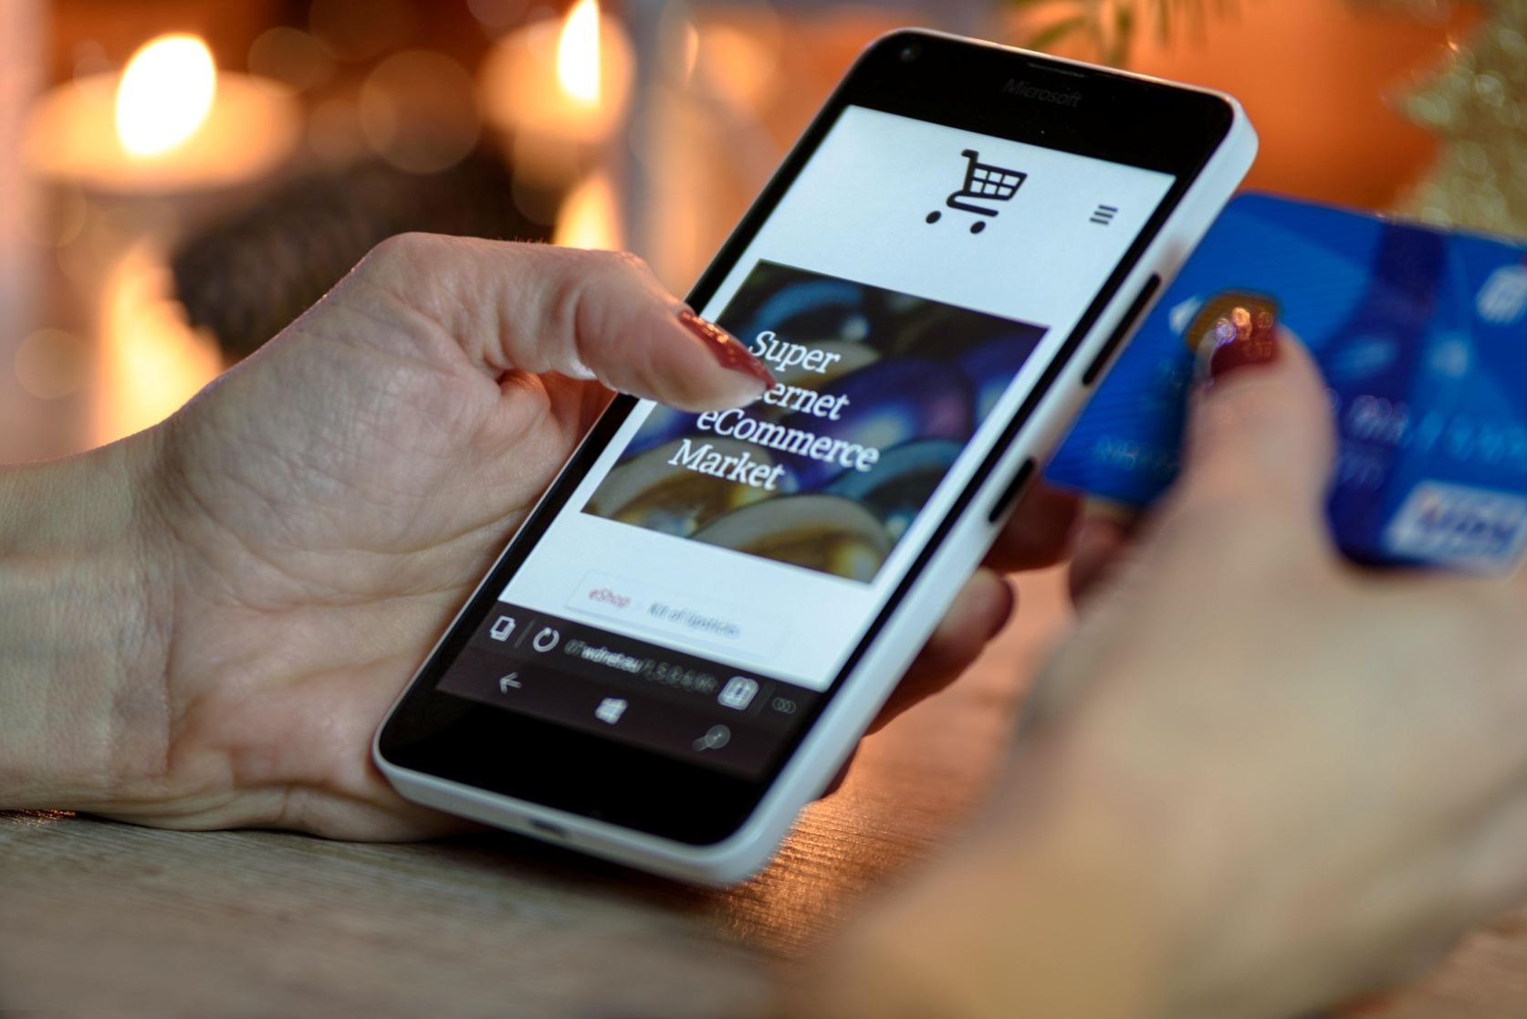

* Automated Teller Machines – Often commonly abbreviated as ATM, this channel also involves the use of bank cards. It is an electronic telecoms device that enables customers of financial institutions to perform financial transactions, such as cash withdrawals, deposits, transfer funds, or obtaining information at any time and without the need for direct interaction with bank staff.
* Mobile Money –  This channel is a payment solution that enables you pay for goods and services with mobile phones. It has been introduced to the Nigerian economy to promote the CBN’s cashless policy. Mobile Money turns a mobile phone into an electronic wallet (e-wallet). A user can store electronic money in his mobile phone for use in settling bills, making transfers and subscribing for services et cetera.

##### **Statistics pertaining to e-payment channels in Nigeria**

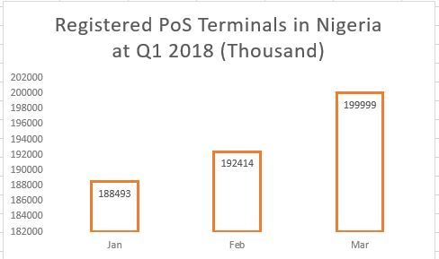

Registered POS terminals in Q1 2018. Source – NIBSS.

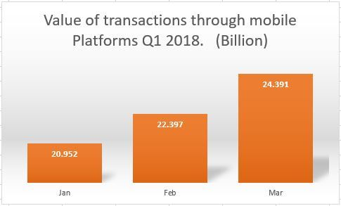

Value of transactions which passed through Mobile Money platforms in Q1 2018. Source – NIBSS.

##### **Latest Trends**

Today, electronic payment has been extended to many services in the economy. The following can now implement electronic means towards serving their customers better and faster –

1. Retail Outlets – they could integrate PoS terminals with their electronic cash registers (ECR). Nevertheless, e-means of transaction are quickly being adopted across Nigeria, due to the desire not to hold too much cash in the stores, and to minimize the time a customer spends at the point of sales.
2. Government – several services are now at the doorstep of government agencies and service providers. These include and are not limited to – collections of taxes, payment for utility bills, fines, duties, license renewals and a whole lot more.
3. Electronic commerce – the integration of payment gateways into websites, that are used for buying and selling, has become a standard these days. So, it saves the customer time, by not being at the physical shop. It also changes the perception of the business in the area of technological receptivity. In addition, e-commerce platforms which have implemented online payment solutions have cemented their reputation as those who have gone beyond the **brick and mortar**business model.
4. Agent networks – today, thanks to PoS cashback and Mobile Money services, agents have begun to realise that, there is a need to bridge the gap between the financially underserved and those who have active access to financial services. Therefore Mobile money and cashback services can be used to save money and hold less cash, pay for projects, make transfers at the bureaux-des-changes or the parallel currency exchange markets, subscribe for services, open accounts, make deposits and withdrawals.

##### **What the future holds for e-payment in Nigeria**

* The impact of the Generation Z (that is the generation born after the millennials – from 2001 till date) is going to be great, because a whole lot them are tilting towards doing cashless transactions. They are the generation born in the new millenium, when the internet revolution had just reached Nigeria. They are going to need banks to digitize their monies and vendors and suppliers to accept digitized money – thus e-payment is going to cement its place in the Nigerian economy in the not-distant future.
* The level of customer experience demanded from service providers and vendors is rapidly rising to newer levels because of competition, improvement in tastes and preferences, and customers easily getting bored with monotonous methods of being served. Business outfits may have to dance to the tune of the next generation – they need to be able to encourage transaction convenience and e-payment product and service extensions which will bring about flexibility.
* Digital wallets are going to be a norm – PoS terminals are going to get smaller and smaller to enable ease in mobility. Vendors and service providers are going to accept mobile payments and savings as norm.
* Cards are likely to compete with codes – Payment devices are already being installed with capabilities such as barcode scanners and biometric scanners. With the introduction of EMV, each account will become the foundation for a code that changes with each transaction, for security purposes. Payments will thus become more virtual.

LINKS-

<https://files.eric.ed.gov/fulltext/EJ1079942.pdf>

<http://www.transcampus.org/JORINDV13DEC2015/Jorind%20Vol13%20No2%20Dec%20Chapter18.pdf>

<https://www.usaid.gov/sites/default/files/documents/1860/Enabling_Market_Conditions_for_Pay-As-You-Go_Solar_Executive_Summary.pdf>

<https://www.researchgate.net/publication/283321608_The_Effects_of_Electronic_Banking_on_Growth_of_Deposit_Money_Banks_in_Nigeria>

<https://www.cbn.gov.ng/OUT/PUBLICATIONS/BSD/2003/E-BANKINGRPT.PDF>

### Mobile Wallets & Payment Systems

**Evolution of The Nigerian Payments System**

Over the last decade, the Nigerian payments system has evolved from manually processed cash transactions to online and real-time electronic payments system. This evolution is in response to growing commercial activities and the penetration and utilization of the cyber space/technology for commercial activities. It is no more necessary for Merchants to display their wares physically for the inspection of consumers, an online store, is just as efficient, if not more so.

Consumers world over can access and order goods and services via mobile gadgets and technologies. This development ultimately required an effective, efficient, and secured means of settlement of transactions. The established and then conventional means of cash settlement of payment has become inefficient and time consuming. Consequently, local and international companies ventured into this new goldmine of opportunities and began to provide solutions and services to solve this problem. This marked the beginning of a new era in Nigeria’s payments system.

 Notwithstanding the success recorded and the merit of these new methods of payment, there was a need for proper regulation and a necessity to set clear defined boundaries regarding the roles and rights of parties and the extent of operations of the different players in this industry.

In that regard, the Central Bank of Nigeria (“CBN”), empowered by law, being the overall regulator of the country’s financial system, rose to the occasion.

**History of the Regulatory Regime**

The CBN has wide powers to regulate matters concerning Nigeria’s fiscal and monetary policies. Section 47 (2) and (3) of the Central Bank of Nigeria (Establishment) Act (the “Act”) empowers the CBN to promote and facilitate the development of efficient and effective systems for settlement of transactions (including development of electronic payment systems). The CBN is also empowered to prescribe rules and regulations for the effective operations of all clearing and settlement systems.

 Until a few years ago, the CBN was not as technically equipped as it is today to regulate and control electronic payment systems in Nigeria and as a result, most of the activities in the sector was unregulated. Then, the CBN merely issued letters of authorization to companies desirous of operating payment systems in Nigeria. However, in 2007, CBN launched the Payment Systems Vision 2020 which identified series of recommendations to increase the resilience of the payments system infrastructure and work-streams to encourage the usage of electronic payment methods. It was aimed at facilitating economic activities by providing safe and efficient mechanisms for making and receiving payments with minimum risks to the CBN, payment service providers and end users, extending the availability and usage to all sectors and geographies, banked and unbanked, and conforming to internationally accepted regulatory, technical and operational standards. In line with the above objectives, the CBN began to develop the technical ability necessary to regulate the industry and it also began to put in place necessary regulatory framework to achieve these goals. As a result, it is becoming increasingly difficult to do anything in the Nigerian payments industry without requiring the approval of the CBN.

 Very recently, the CBN through a letter advised that although it has not developed guidelines for the regulation of the operators of web payment portals and gateways, any company desirous of operating a web payment portal or gateway must apply and obtain a Payment Solution System Service Providers (“PSSP”) licence. The idea is that the CBN intends to bring all entities and parties participating in the Nigerian payments system within its reach for ease of control and supervision.

 We have discussed the existing regulations below and the consequences of operating without obtaining a licence from the CBN or in breach of the terms and conditions of a licence granted by the CBN.

**Current Regulatory Regime**

 In exercise of its powers, the CBN has issued various guidelines to prescribe rules and regulations for the effective operations of all clearing and settlement systems. Some of these guidelines include:

1. Guidelines on Electronic Payment of Salaries, Pensions, Suppliers and Taxes in Nigeria, February, 2014;
2. Guidelines on Transactions Switching Services;
3. Guidelines on Point of Sale (POS) Card Acceptance Services; and
4. Regulatory Framework for Mobile Payments Services in Nigeria.

The above guidelines regulate all the operators in the Nigerian payments system and also prescribes sanctions for erring service providers. On 9th July, 2015, the CBN published a circular titled ‘Sanctions on erring banks and e – payment service providers for infractions of payments rules and regulations’. This circular prescribes the appropriate sanction to be imposed on an operator in the Nigerian payments system for infringements of extant guidelines, circulars, rules and regulations issued by the CBN on all forms of electronic payments system.

 Recently, on 9th September, 2015, the CBN released an exposure draft of the Standards and Guidelines on Electronic Channels Operations in Nigeria for the public’s review and comments. The public is expected to review and forward recommendations to the CBN on this guidelines to enable it capture the opinion of industry practitioners and operators. When implemented, this guidelines will codify most of CBN’s existing guidelines on all electronic payments system in Nigeria.

 The following are relevant operators in the Nigerian payments system industry, Card Holders, Merchants, Merchant Acquirers, Card Schemes, Payment Solution System Service Providers (“PSSP”), Switching Companies, Internet Service Providers, Issuing Banks, Nigerian Central Switch, Nigeria Inter-Bank Settlement System, Payments Terminal Service Aggregator (PTSA) etc.

 No entity or company can provide any services within the Nigerian payments system without  obtaining a licence from the CBN.

LINKS-

<https://www.cbn.gov.ng/out/circulars/bod/2009/regulatory%20framework%20%20for%20mobile%20payments%20services%20in%20nigeria.pdF>

<https://www.cbn.gov.ng/out/2014/bpsd/exposure%20draft%20guidelines%20on%20mobile%20payments%20services%20in%20nigeria%20.pdf>

<http://www.efina.org.ng/assets/Documents/EFInAScoping-Study-on-Payment-Systems-in-NigeriaSupply-Side-Key-Findings-Aug-2010.pdf?phpMyAdmin>=

<http://documents.worldbank.org/curated/en/575771468098970368/pdf/950190WP0Box380ping0Reports0Nigeria.pdf>

<https://www.businesswire.com/news/home/20180502006176/en/Nigeria-Mobile-Wallet-Payment-Market-Opportunities-Databook>

### FinTech

According to [PWC 2017 FinTech Survey Report](https://www.pwc.com/ng/en/pdf/nigeria-fintech-report-2017.pdf), over 62% of customers will use mobile applications to access financial services within the next 5 years.

The word [FinTech](https://www.investopedia.com/terms/f/fintech.asp" \t "_blank) is a combination of the words “financial technology”. While the term has been around for several years, it seems that 2015 is really the year that this fledgling offshoot of the larger banking industry has finally come into its own.

But what is FinTech, and how is it impacting business growth in Nigeria?

## What Is FinTech?

FinTech, or Financial Technology, refers to new technology or innovation that disrupts traditional ways of conducting financial transactions. This includes digitizing processes that were previously handled with paper money and human interaction.

*The term financial technology can apply to any innovation in how people transact business, from the invention of digital money to double-entry bookkeeping.*

FinTech is not new. It’s been around in one form or another virtually as long as financial services have. After the global financial crisis of 2008, FinTech has evolved to disrupt and reshape commerce, payments, investment, asset management, insurance, clearance and settlement of securities and even money itself with cryptocurrencies such as [Bitcoin](https://www.coindesk.com/information/what-is-bitcoin/" \t "_blank).

***Also Read:***[***How BlockChain Can Drive Economic & Business Growth In Nigeria***](https://invoice.ng/blog/blockchain-technology-in-nigeria/)***.***

## Key Areas Of Impact

The rise of the smartphone has massively changed the behavior of consumers. Whether it’s checking to pay for goods online or making bank transfer via a mobile app, Nigerians are now getting used to handling financial affairs as easily and conveniently as they do their email or Facebook page.

This is considered a good opportunity for news startup businesses and its the major reason for the disruption we are witnessing today.

### 1. Banking

FinTech is the major cause of all the recent disruptions we are experiencing in the Nigeria banking sector today (With the likes of [ALAT](http://www.alat.ng/) by Wema Bank & [GTBanks 737](http://www.gtbank.com/737/" \t "_blank)). Now you can access top-notch financial services without stepping into a bank.

Fintech uses technology in a better way to make people feel convenient living in the modern age. FinTech helps people who are ‘unbanked’ but a desire to buy or sell online have access to quick and affordable banking operations just by using a mobile phone.

### 2. Payments

The Nigerian payments landscape has significantly evolved over the past decade. The cost of integrating online payments to a website 5 years ago was over 150k now thanks to FinTech, the cost of accepting online payments is Zero.

With the rapid adaptation of card payments in Nigeria, platforms like [Flutterwave](https://www.flutterwave.com/" \t "_blank) and [Paystack](https://paystack.com/" \t "_blank) are playing the lead role in making it easy for businesses to start accepting online payments with the click of a button.

### 3. Lending

FinTech has fuelled the growth of alternative lenders which offer both higher yields to investors and faster, cheaper, more convenient loans for borrowers compared to traditional banks.

Private lenders like [PayLater](https://www.paylater.ng/" \t "_blank), [QuickCheck](http://www.quickcheck.ng/" \t "_blank), and [Lidya](https://www.lidya.co/" \t "_blank) are continuing to plow hundreds of millions of naira into alternative-lending space in Nigeria making it easy for anyone to access quick loans (business or personal) when needed.

***Also Read:***[***Key Benefits of Online Payments for Nigerian Small Businesses.***](https://invoice.ng/blog/key-benefits-of-online-payments-for-nigerian-small-businesses/)

### 4. Financial Management

FinTech is changing the way we manage our money for the better. FinTech startups are introducing simple ways to manage and track your finances.

Instead of relying on a pen and paper or spreadsheet, you can now use digital financial solutions to manage your finances in real time. Good examples of Nigerian startups playing in this space are [PiggyBank](https://www.piggybank.ng/" \t "_blank) for saving, [Invoice NG](https://invoice.ng/) for invoicing and [Kliqr](https://www.kliqr.com/" \t "_blank) for expense management.

## Conclusion

The rise of FinTech has opened up a world of possibilities for [small businesses](https://invoice.ng/blog/category/small-business/). Businesses can offer more services than ever and for a fraction of the price of what it would have cost before. Other new technologies, like machine learning, artificial intelligence, predictive behavioral analytics, and data-driven marketing, will take the guesswork and habit out of financial decisions.

Forward-thinking Entrepreneurs & Business Owners need to continuously keep up to date with FinTech developments as a vital part of their daily life. Being aware of the latest opportunities and developments within the field will only improve your business and help you stay at the forefront of your market.

LINKS-

<https://www.pwc.com/ng/en/pdf/nigeria-fintech-report-2017.pdf>

<https://www.researchgate.net/publication/313040251_Nigeria_Investing_in_a_Cashless_Future>

<https://assets.kpmg.com/content/dam/kpmg/ng/pdf/ng-fintech-in-nigeria-understanding-the-value-proposition.pdf>

<https://iclg.com/practice-areas/fintech-laws-and-regulations/nigeria>